[CEN 323 ] Computer Organization & Assembly Language
Lab 7 Journal

Name : Fatima Asad
Enrollment Number: 01-135232-020

Lab Deliverables (submission guideline)

Create a folder named after your enrollment number and add the following files:
  - Create a folder named YourRollNumber_Lab7 containing:
- .asm files of the three practice tasks.
- Add full screen screenshots of the code and output in this word file.
  - Zip the Folder and upload to LMS.

Lab Task

Task 1:
Code (TEXT):
include emu8086.inc
org 100h

.code
mov bl, '5'
mov dl, 5
mov dh, 0

outer_loop:

cmp dh, 0
je spaces
mov cl, dh

space:
putc ' '
loop space

spaces:
mov al, bl
sub al, '0'
mov cl, al
add cl, al
dec cl

inner_loop:
putc bl
loop inner_loop

printn ""
dec bl
inc dh
dec dl
jnz outer_loop

Screenshot (CODE):
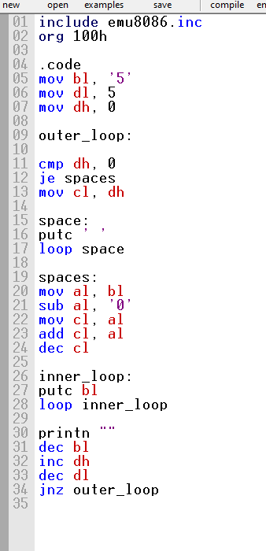

Screenshot (OUTPUT):
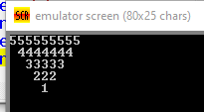

Task 2:
Code (TEXT):
include emu8086.inc
org 100h

.code
mov bl, 1
mov dh, 3

outer:
cmp dh, 0
je skipspaces
mov cl, dh

spaceloop:
putc ' '
loop spaceloop

skipspaces:
mov al, bl

descloop:
mov cl, al
add cl, '0'
putc cl
dec al
jnz descloop

mov al, 2

ascloop:
cmp al, bl
jg ascdone
mov cl, al
add cl, '0'
putc cl
inc al
jmp ascloop

ascdone:
printn ""
inc bl
dec dh
cmp bl, 5
jne outer

Screenshot (CODE):
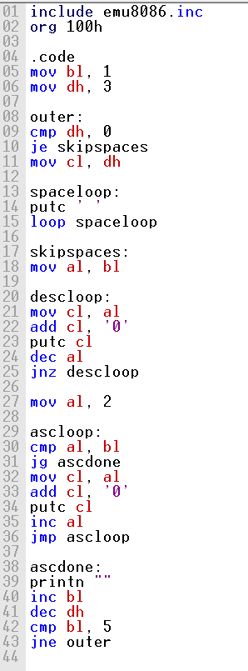

Screenshot (OUTPUT):
